**Project Title**

**Design and simulate a brake disc optimized for weight reduction, heat dissipation, and structural integrity.**

**Name : SHUBHAM SHARNAGAT**

**Roll No. - 241050081**

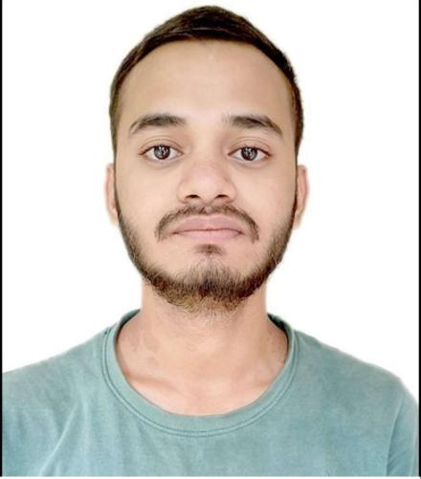

**Course No. ME670**

**Academic year 2024- 25**

**Date 21/11/2024**

**Contents**

**Abstract**

**1. Introduction and Background**

**2. Problem Definition**

**3. Materials and Methods**

### ****3.1 Materials and Manufacturing Technique****

### ****3.2 Methodology****

### ****3.3 Models and Schematics****

**3.4 Process Perameter for Material**

**3.4.1 Physical properties :-**

## ****4 . Moddeling Approach****

****4.1 . Model 1****

****4.2 . Model 2****

### ****5. Thermal Distortion Prediction****

### ****6. Thermal Gradient Distribution****

**7. Results and Discussion**

1. **Conclusion**
2. **References**

**Abstract**

This project investigates the design and simulation of a disk brake produced using additive manufacturing (AM), focusing on predicting and optimizing distortion caused by thermal gradients during braking. By employing topology optimization and thermal-structural simulations, the brake design was optimized for minimal deformation under high-temperature gradients. Distortion was reduced by strategically modifying the geometry and using AM-specific strategies such as internal cooling channels. The study demonstrates the benefits of AM in minimizing thermal distortion while improving brake performance.

**Keywords:** Disk brake, additive manufacturing, thermal distortion, topology optimization, thermal gradient, simulation

**1. Introduction and Background**

Disk brakes are essential components for energy dissipation in vehicles, where kinetic energy is converted to heat during braking. However, significant temperature gradients lead to thermal distortion, adversely affecting performance, safety, and lifespan. Traditional manufacturing methods struggle to incorporate distortion-minimizing geometries.

Additive manufacturing (AM) enables the creation of geometrically complex components, such as internal cooling channels, that help manage thermal gradients. This study uses AM to design a disk brake and predict thermal distortions through simulation. Optimization techniques were applied to minimize these distortions while maintaining structural integrity.

By utilizing Fusion 360 and Netfabb software for design and simulation, the project explores the potential of AM to produce high-performance components tailored to meet stringent operational demands. The outcomes are expected to demonstrate how modern tools and methods can revolutionize automotive component design, paving the way for safer and more efficient braking systems.

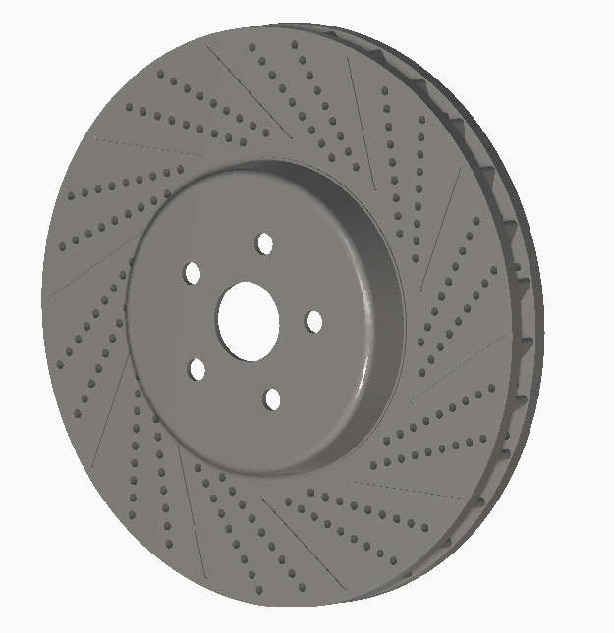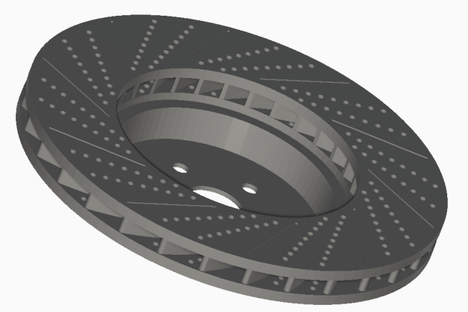

**2. Problem Definition**

**Challenges in Disk Brake Design:**

1. Uneven heating during braking causes thermal gradients, resulting in warping or distortion.
2. Excessive distortion impacts braking efficiency, wear, and noise.
3. Traditional manufacturing techniques limit the ability to optimize designs for thermal distortion.

**Objective:** To design a disk brake using AM techniques that mitigates thermal distortion through improved geometry and materials.

.

**3. Materials and Methods**

### ****3.1 Materials and Manufacturing Technique****

* **Material Selected**: I am using inconel 625 material for Built Plate and Stainless Steel 17-4 PH for the model (brake disc) .
  + Excellent thermal resistance, strength, and low thermal expansion.
* **Manufacturing Technique**: Laser Powder Bed Fusion (LPBF) is used for manufacturing technique for the design .
  + Ideal for creating intricate geometries like internal cooling channels.

### ****3.2 Methodology****

**Design Optimization**:

* 1. Initial CAD design modeled in Fusion 360 with uniform material distribution.
  2. Integrated cooling channels to dissipate heat effectively in fusion 360.

**Thermal-Structural Simulation**:

* 1. **Tools Used**: Fusion 360 for initial simulations and Netfabb for AM-specific analysis.
  2. **Structural Analysis**: Combined thermal load with clamping forces and braking torque.
  3. Predicted distortion due to temperature gradients.

**Optimization Strategy**:

* 1. Identified regions with maximum distortion through simulation.
  2. Adjusted design to improve symmetry and redistribute stresses.

**Boundary and Initial Conditions**:

* 1. Fixed supports at mounting holes.
  2. Initial temperature: 25°C; thermal flux applied on braking surface.
  3. Maximum temperature of bulilt plateform is 150°C.

### ****3.3 Models and Schematics****

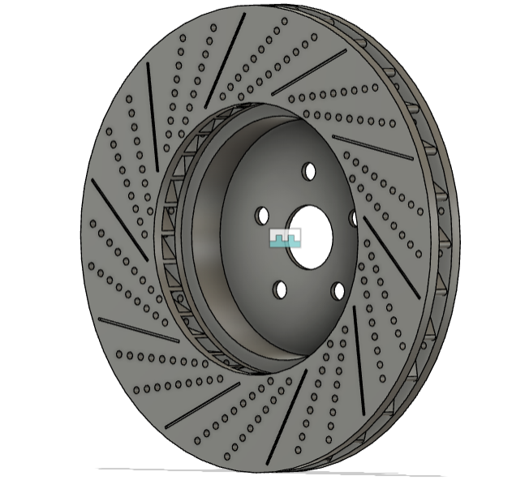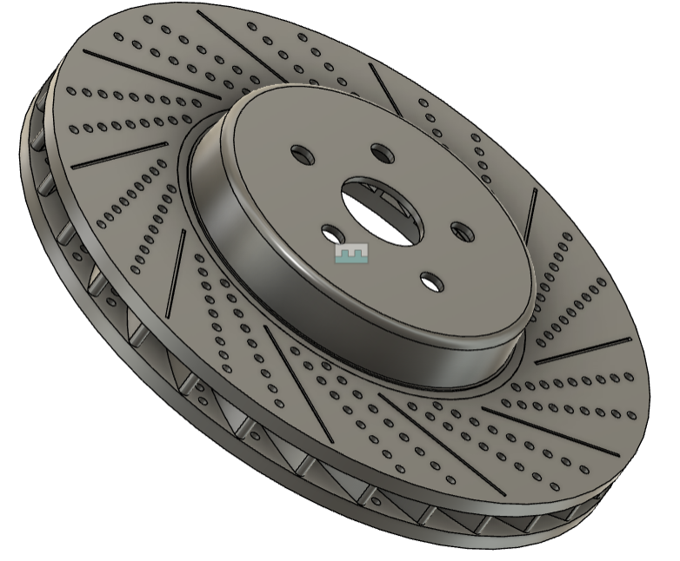

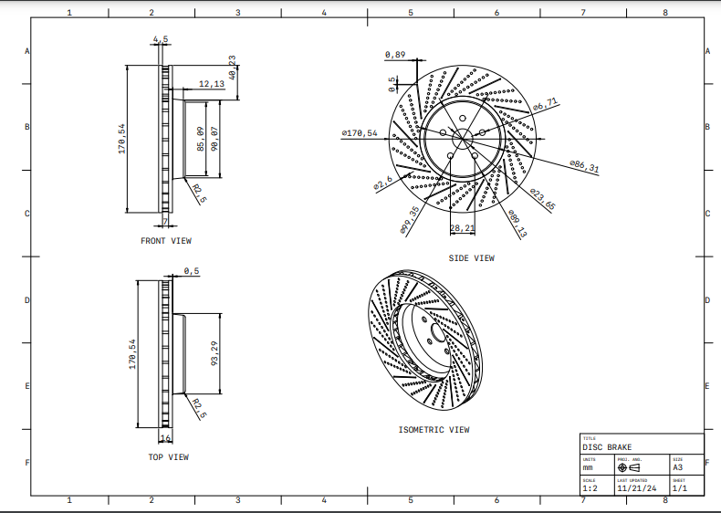

Fig. : CAD model of the optimized disk brake showing internal cooling channels.

**3.4 Process Perameter for Material :**

**3.4.1 Physical properties :-**

|  |
| --- |
| Laser power : 195(W) Heat sourse absorption efficiency : 47% laser beam diameter : 0.1(mm) Travel speed : 1000(m/s) layer thickness : 0.02(mm) Hatch spacing : 0.1(mm) Recoater time : 10(sec) interlayer rotation angle : 67(deg) |

## ****4 .Moddeling Approach:****

**Here we are going to use 2 different models of the brake disc in which model is simulated in two different orientations .**

****4.1 Model 1 :** Here, the disc is parallel to the built plate , I.e.,**

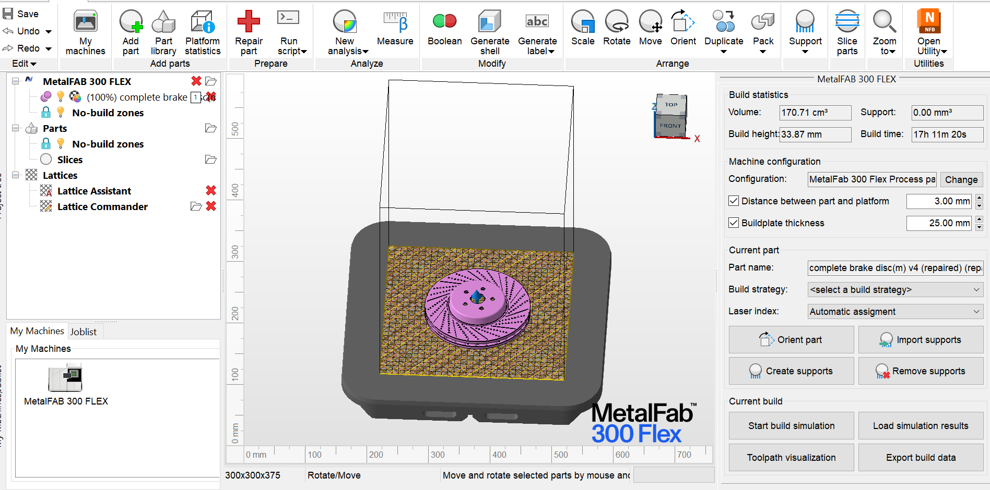

* **Repair model and support structure :**After the complete setup of the machineing in autodesk netfebb 2025, thenwe will do the repairing of the model and applying the support structure.

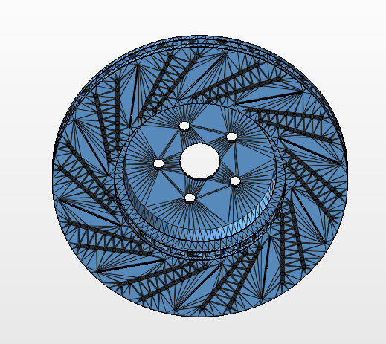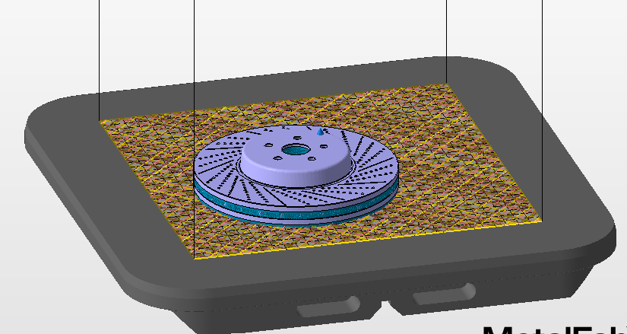

* **Constraints :**  Applying some constraints to the built plate for simpulations as,

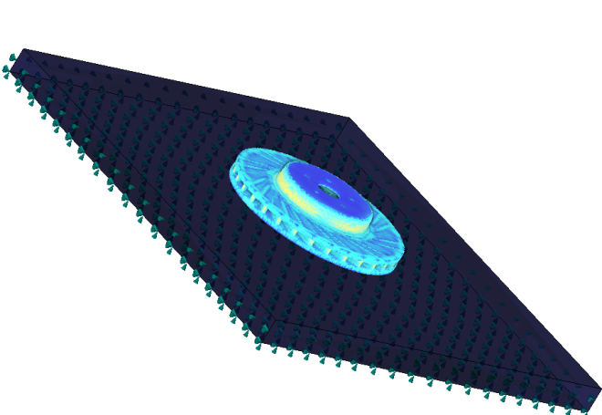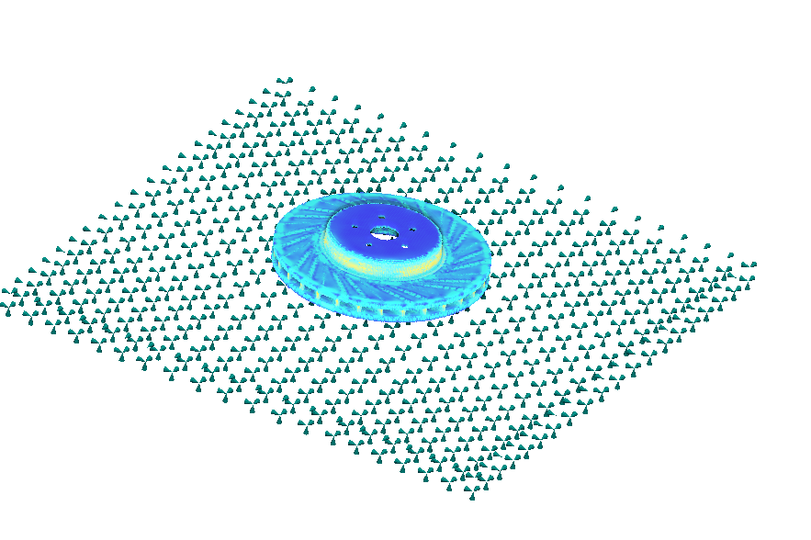

* **Simulation** : After supplying support structure w’ll start the simulation of the model , and getting the following results :
* **Cauchy stress analysis :** By simulation, we found the variation of the cauchy stress produced in model during manufacturing. The simulation revealed localized areas of high stress concentrated near the mounting holes and outer edges during operational loads. These regions were optimized for material distribution to minimize stress concentrations.

|  |  |
| --- | --- |
|  |  |
|  |  |

* **Displacement Analysis :** After simulation , we got some results of the displacement of the disc during simulation of manufacturing .The maximum displacement observed was within the permissible range, ensuring that deformation does not interfere with functionality.

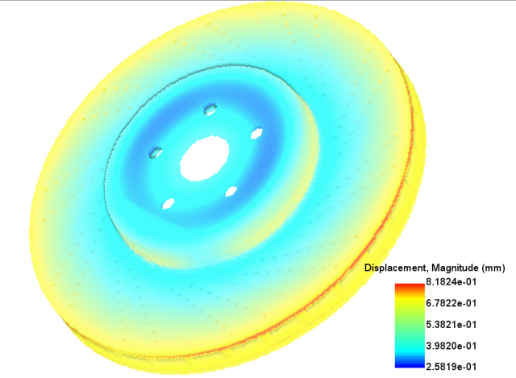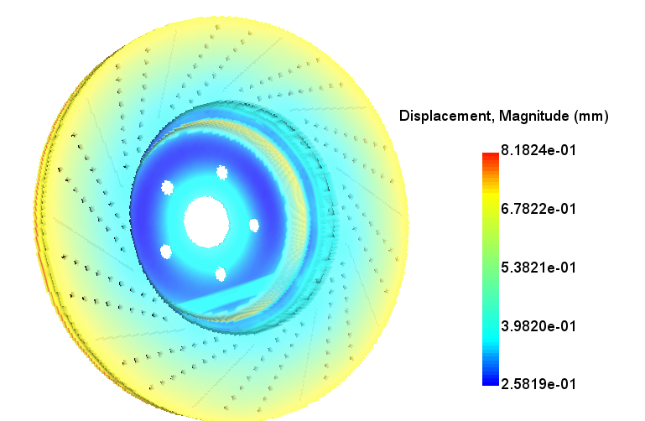

* **Elastic Strain :**  **:**Elastic strain was analyzed to assess the material's deformation under braking loads, showing uniform strain distribution after optimization.

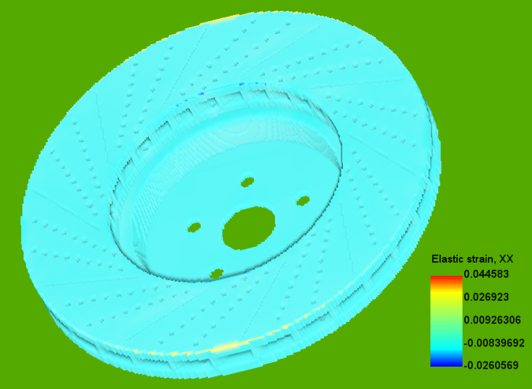

* **Global Recoater clearance % & status :** The recoater clearance remained above the required threshold throughout the build, with 0% interference issues, ensuring smooth manufacturing without collisions.

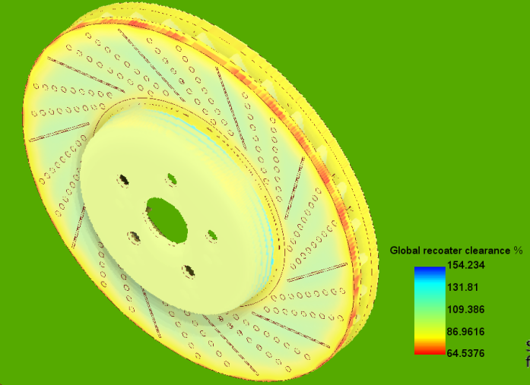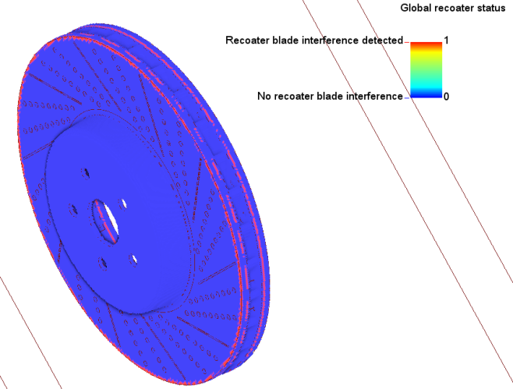

* **Hotspot volume % above 2000 ºC** **:**  Here are some results regarding the hotspot volume % above 2000 ºC

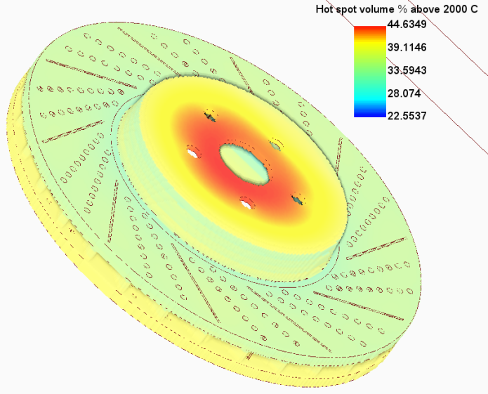

* **Interlayer Temperature :** Layer temperatures remained consistent within the material's thermal conductivity limits, minimizing thermal gradients and potential defects during manufacturing.

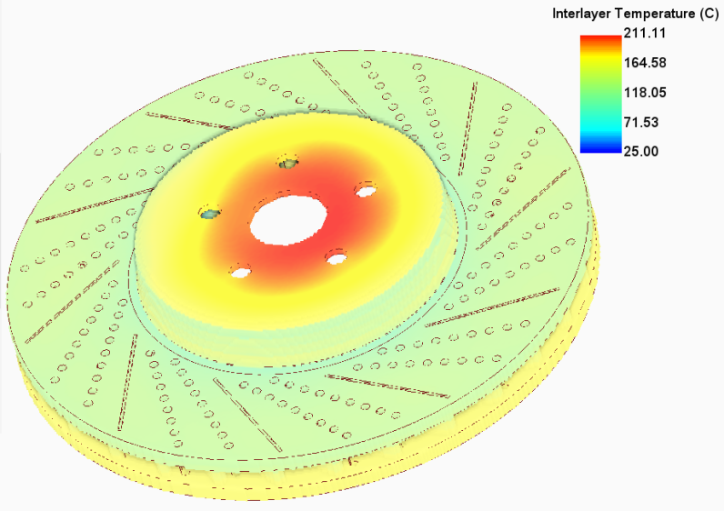

* **Principal Stress Directions Analysis :** The principal stress directions aligned with the applied loads, showing efficient load transfer and minimal deviation in the optimized design.

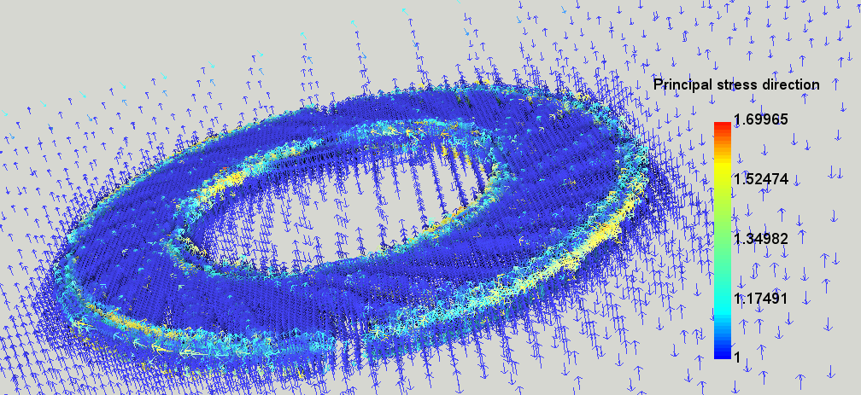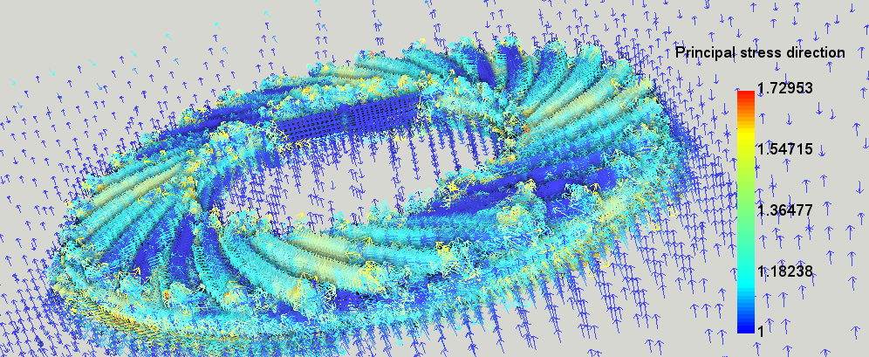

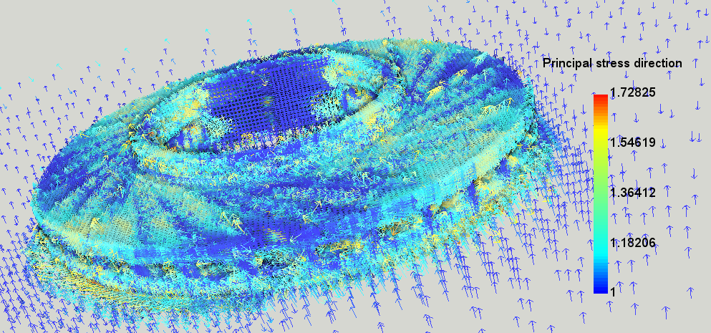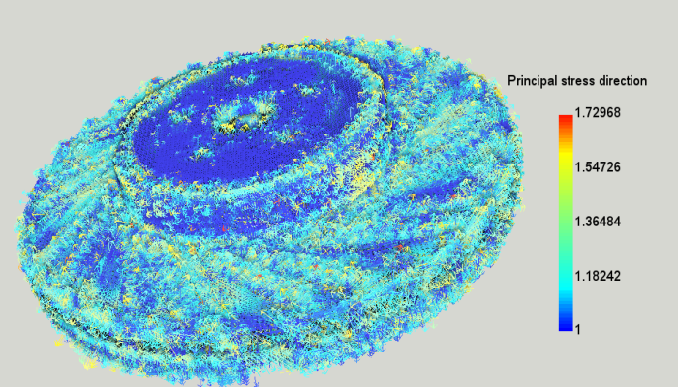

* **Principal stress:** Peak principal stresses were observed near the friction interface and were within the material's yield limit, ensuring structural integrity under braking loads.

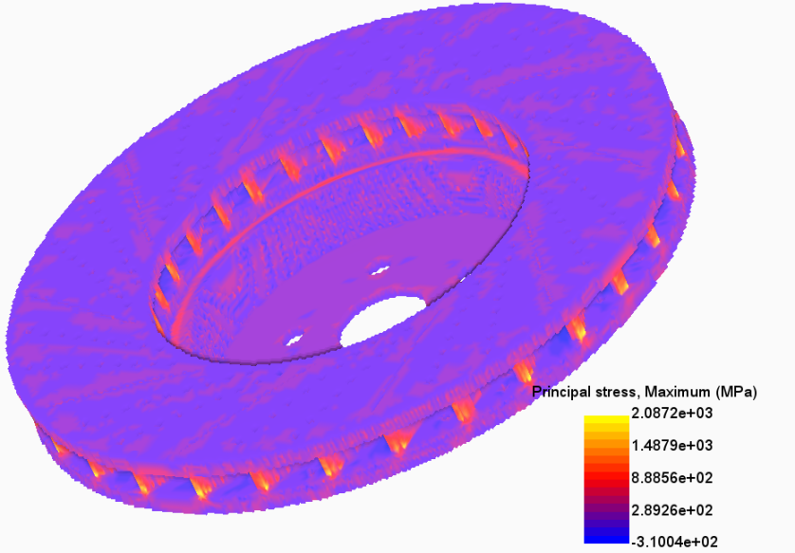

* **Structural Analysis :** The optimized design showed improved stiffness and reduced deformation under braking torque and clamping forces, enhancing overall performance.

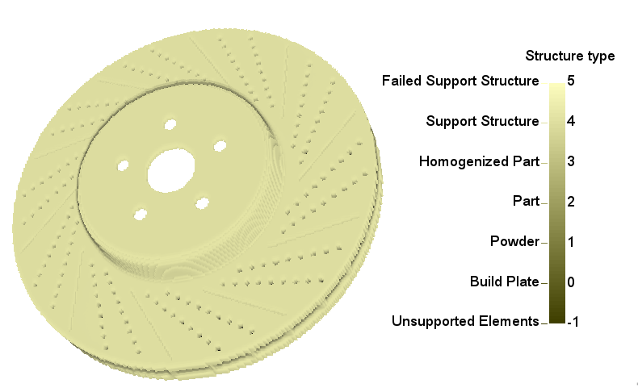

* **Von Mises Stress Analysis :** Von Mises stress was used to predict failure zones, confirming that the design operated well below the material's yield strength, indicating safety and durability.

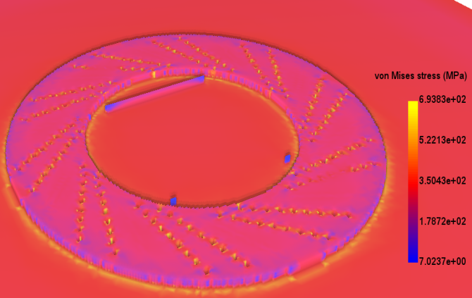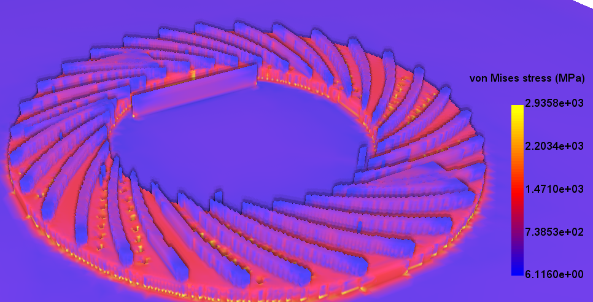

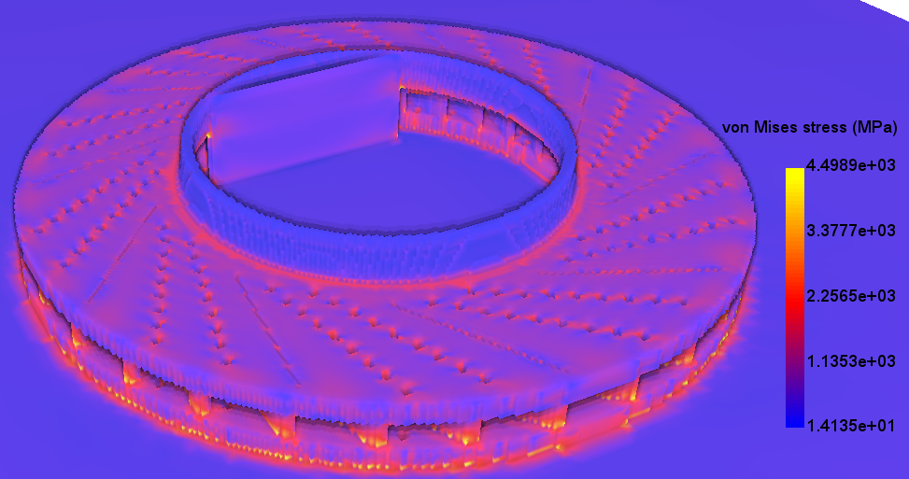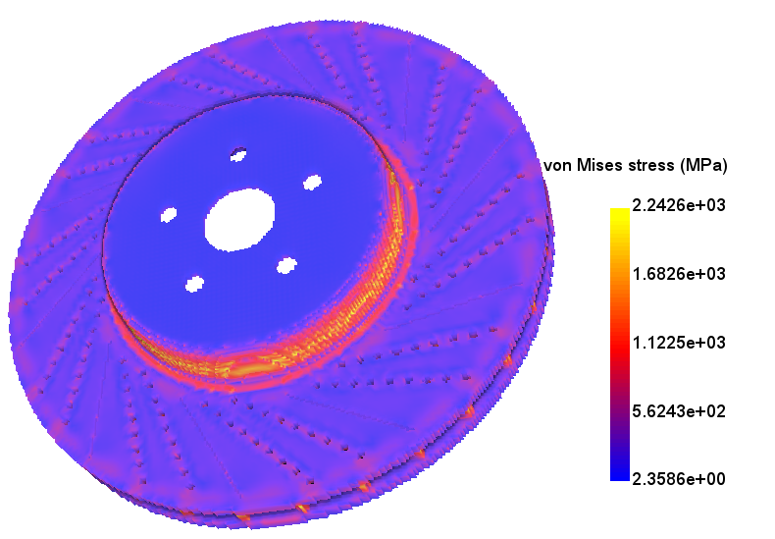

**4.2 Model 2 :** Here model is enclined to the built plate (isometric structure).

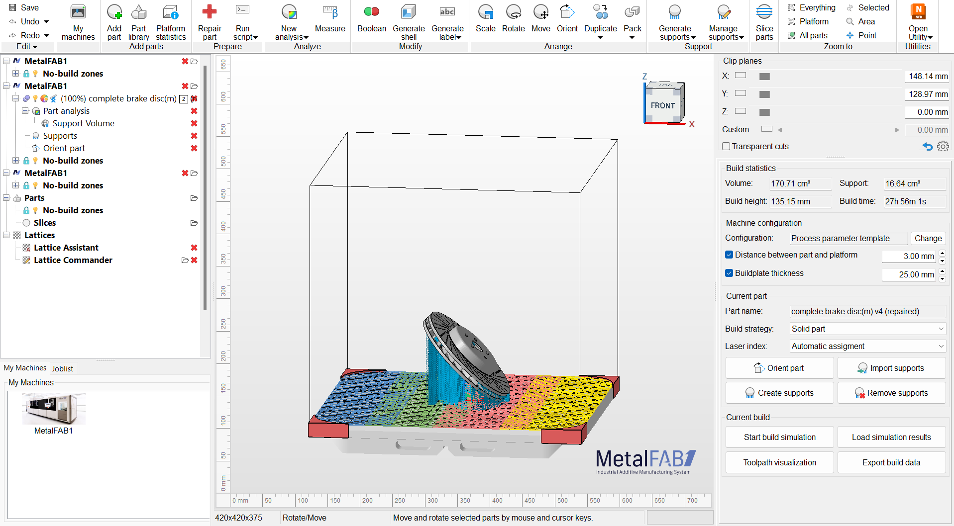

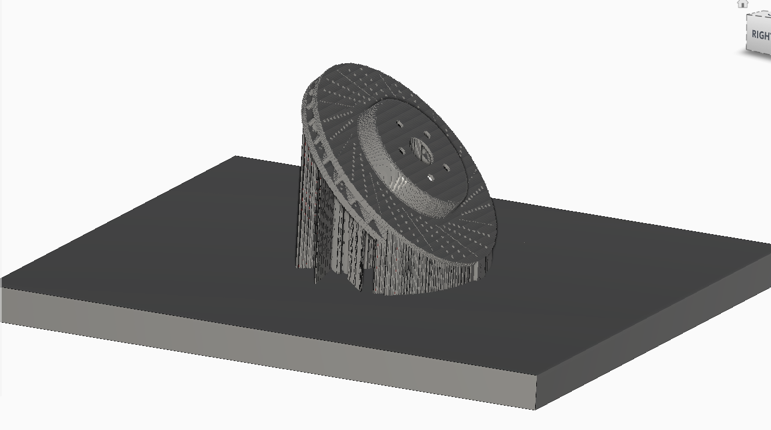

* **Repair model and support structure :** After the complete setup of the machineing in autodesk netfebb 2025, thenwe will do the repairing of the model and applying the support structure.

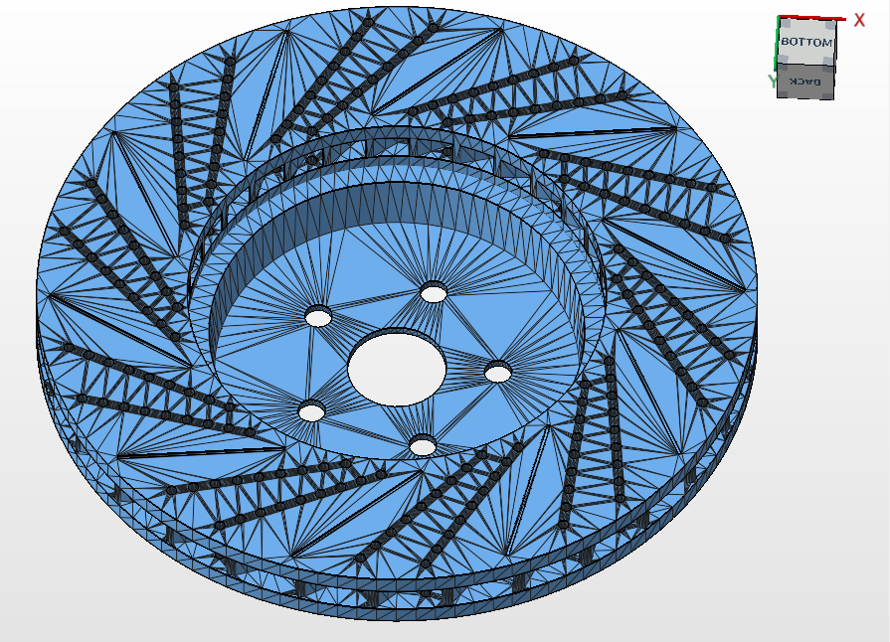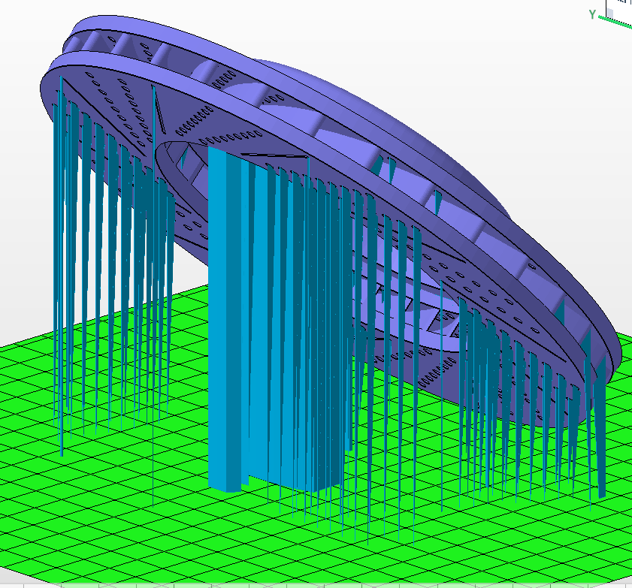

* **Constraints :**  Applying some constraints to the built plate for simpulations as,

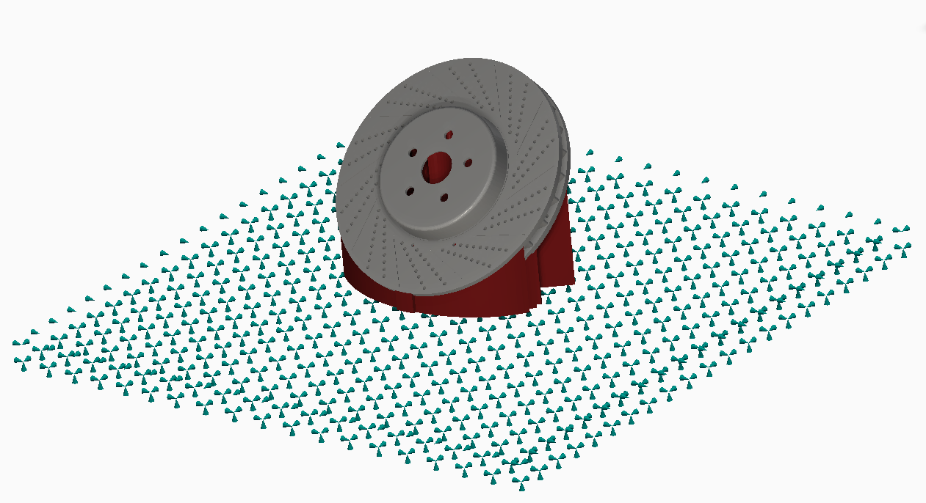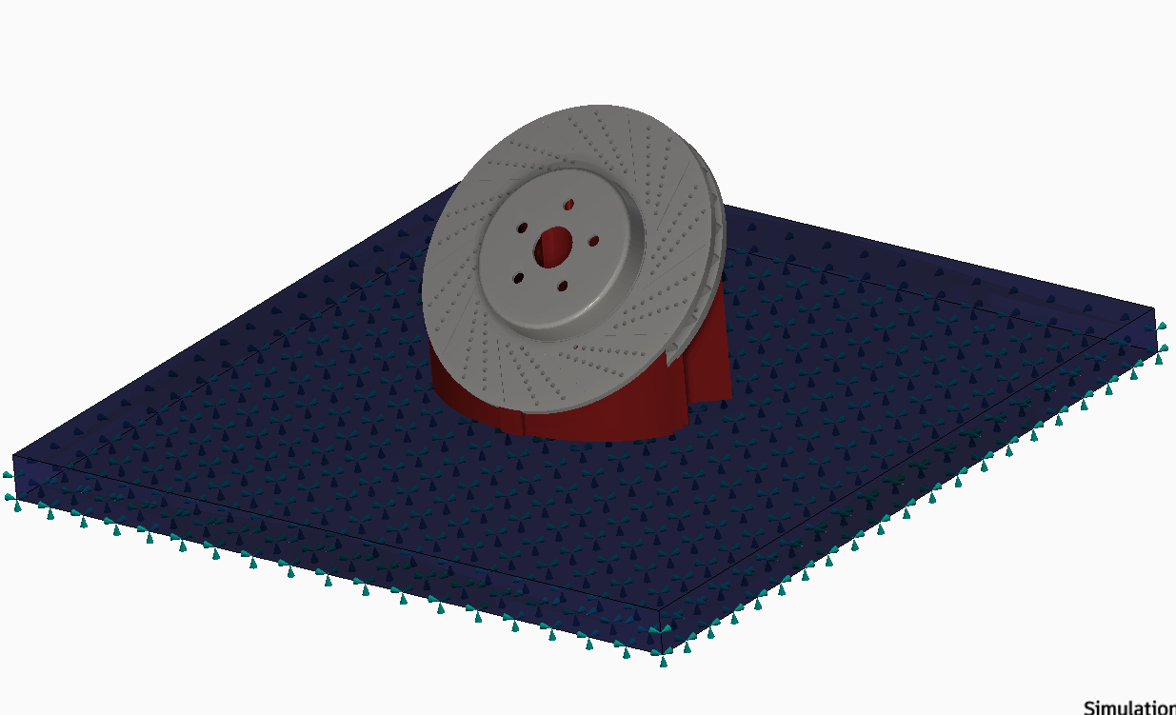

* **Simulation** : After supplying support structure w’ll start the simulation of the model , and getting the following results :-
* **Cauchy Stress Analysis :** The simulation revealed localized areas of high stress concentrated near the mounting holes and outer edges during operational loads. These regions were optimized for material distribution to minimize stress concentrations.

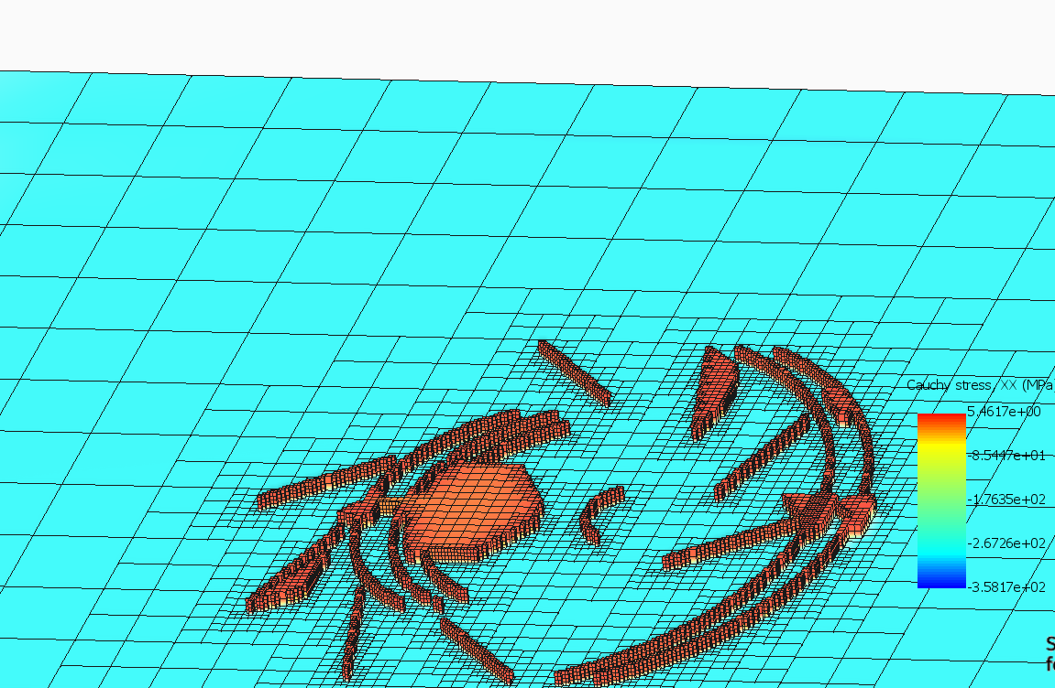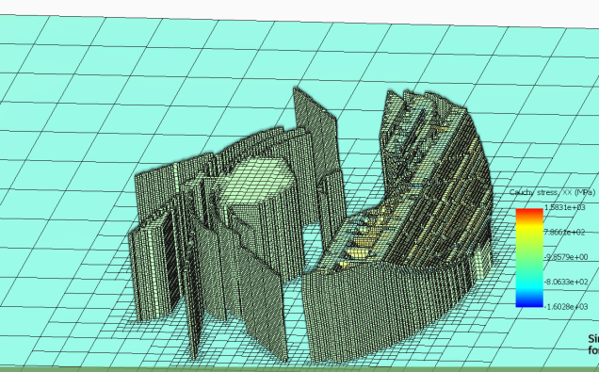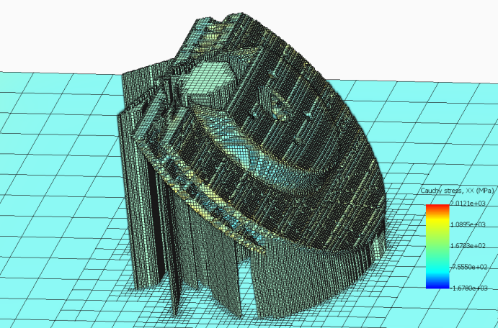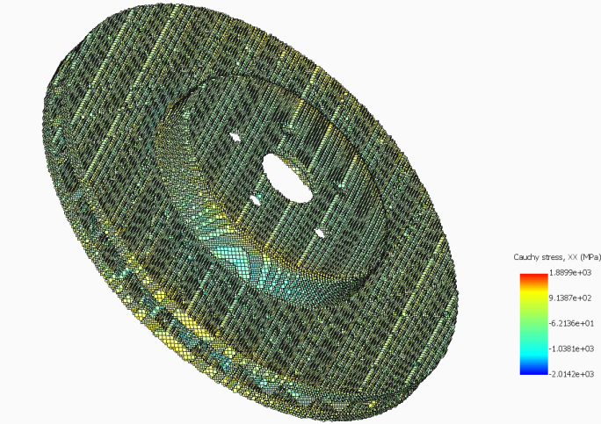

* **Displacement Analysis :** After simulation , we got some results of the displacement of the disc during simulation of manufacturing .The maximum displacement observed was within the permissible range, ensuring that deformation does not interfere with functionality.

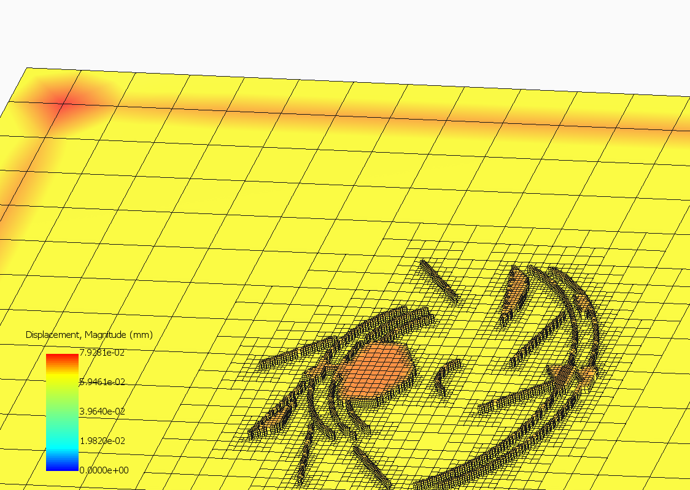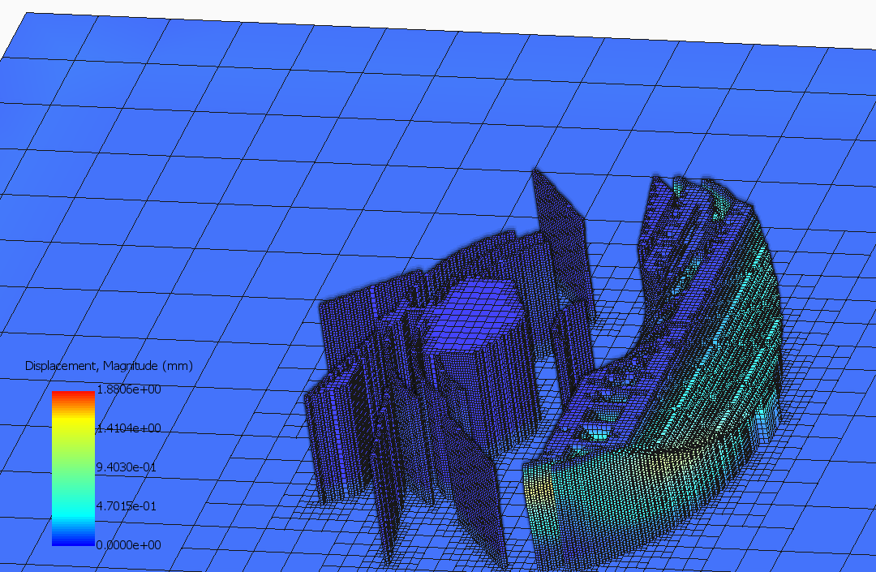

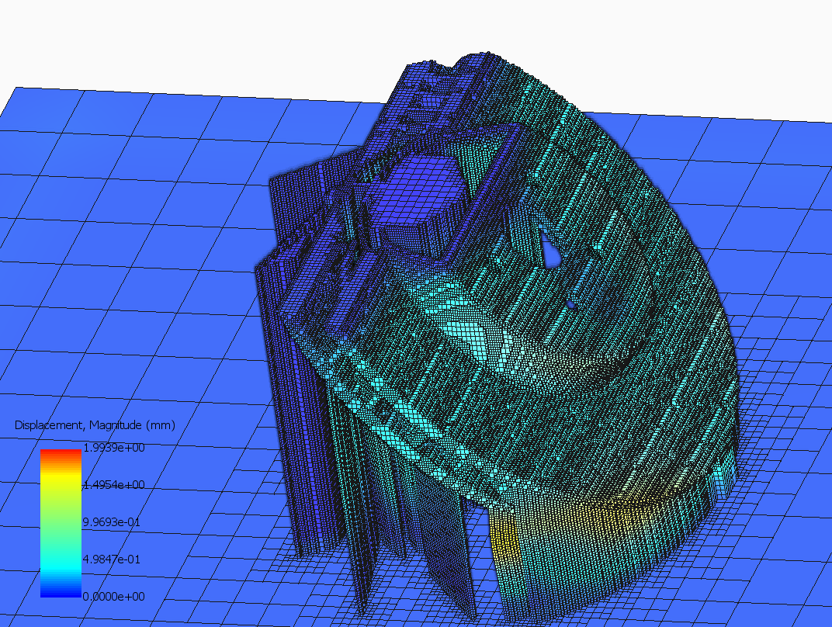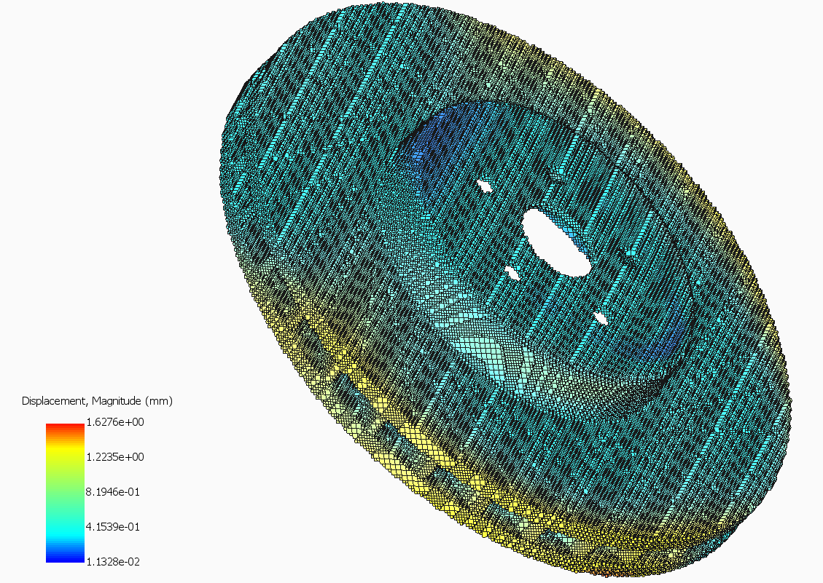

* **Elastic strain analysis:**Elastic strain was analyzed to assess the material's deformation under braking loads, showing uniform strain distribution after optimization.

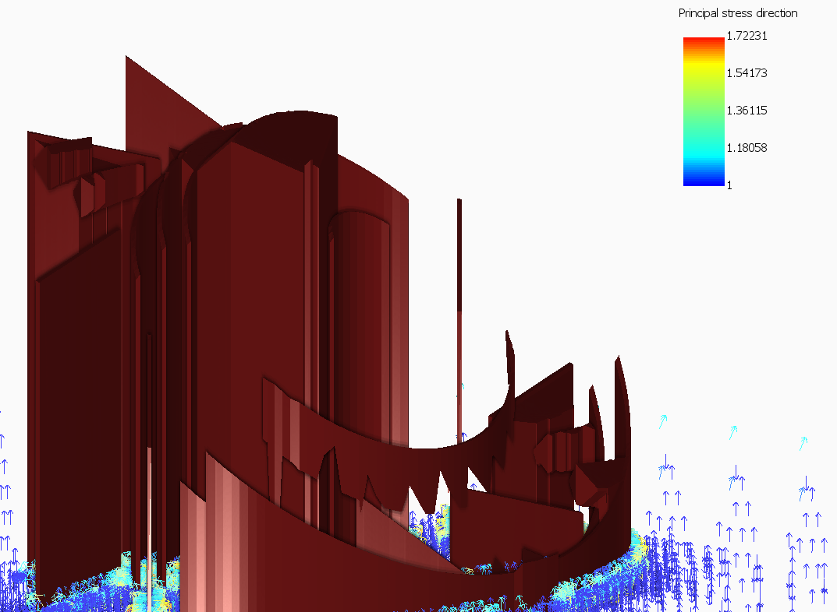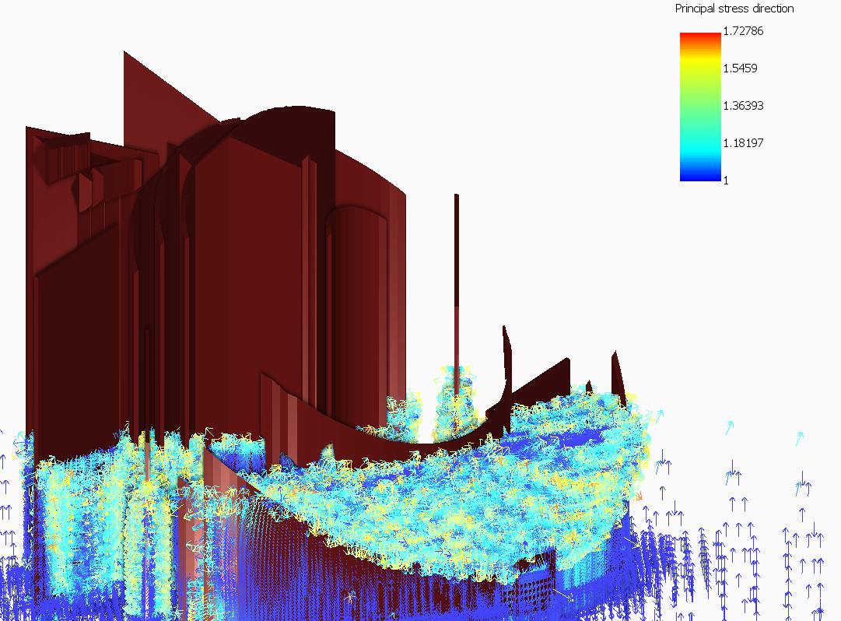

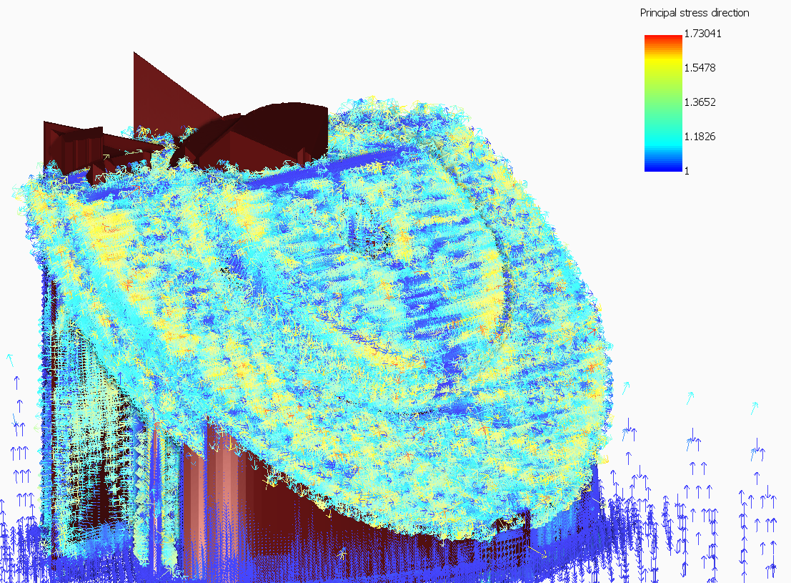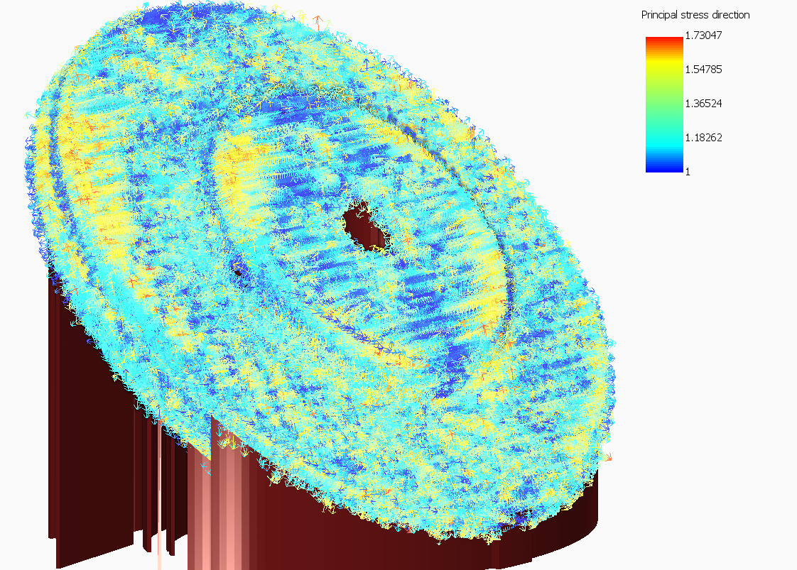

* **Global Recoater Clearance % and Status :** The recoater clearance remained above the required threshold throughout the build, with 0% interference issues, ensuring smooth manufacturing without collisions.

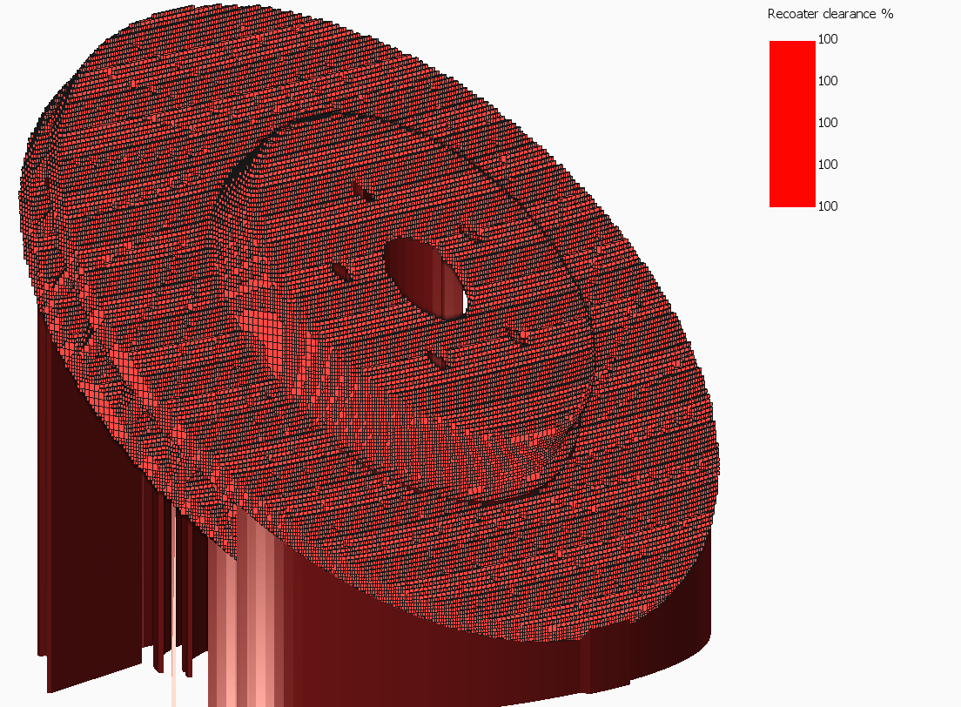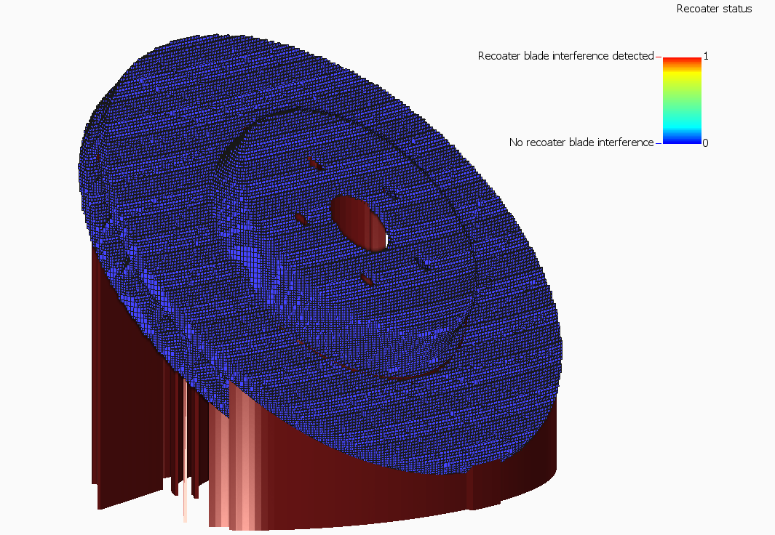

* **Interlayer Temperature :** Layer temperatures remained consistent within the material's thermal conductivity limits, minimizing thermal gradients and potential defects during manufacturing.

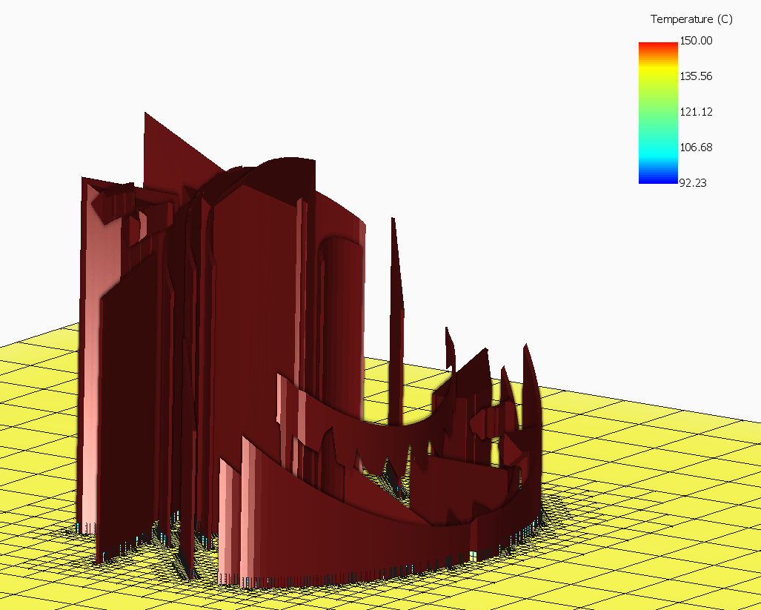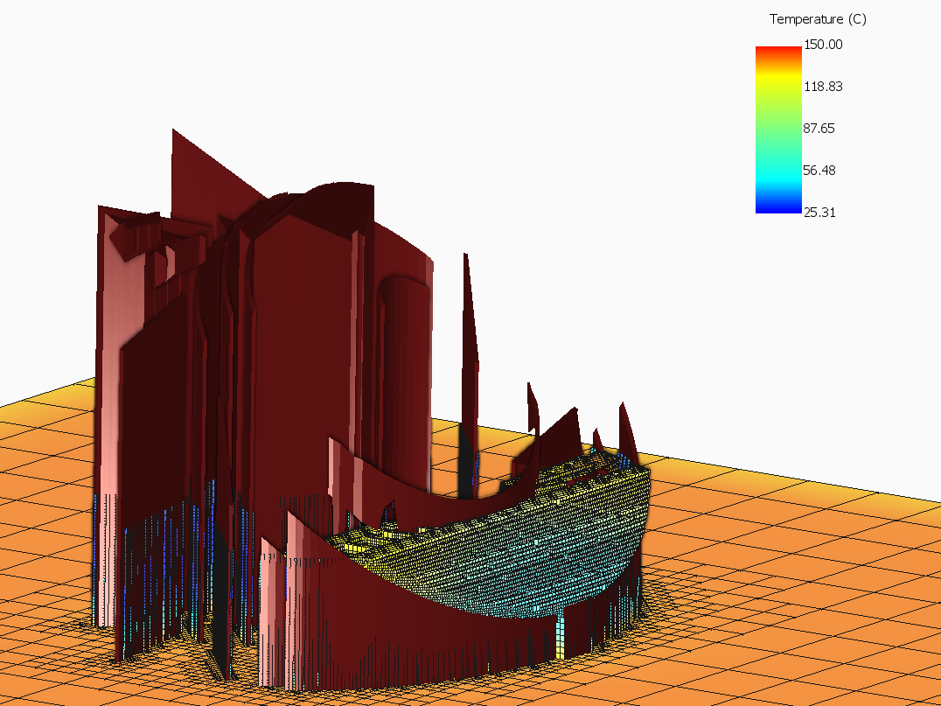

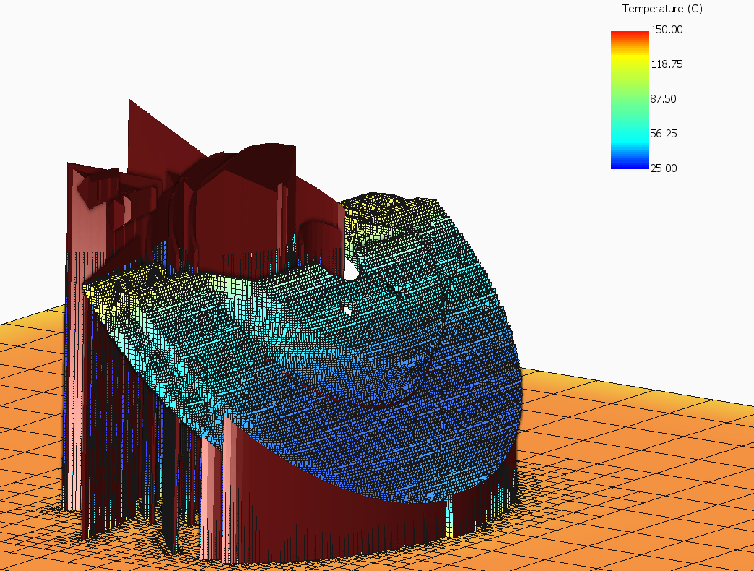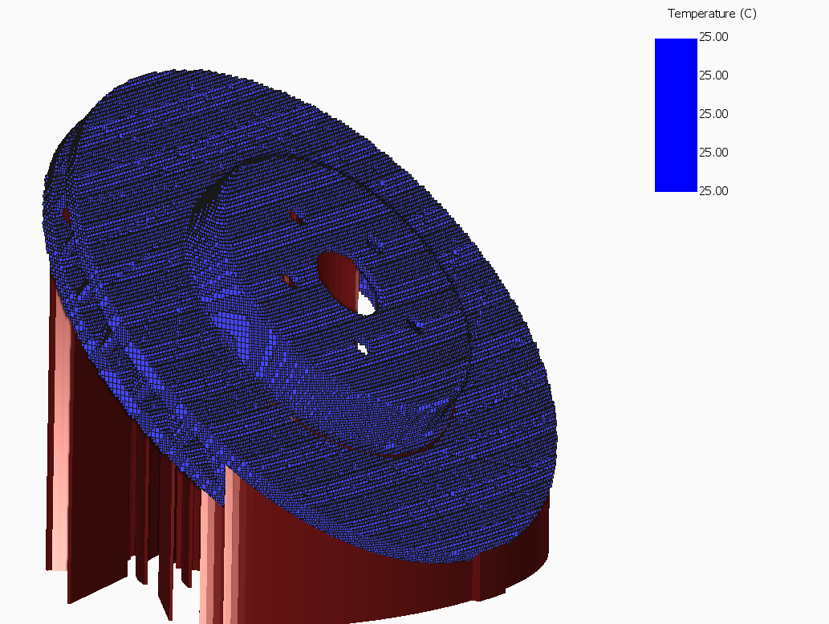

* **Principal stress Direction Analysis :** The principal stress directions aligned with the applied loads, showing efficient load transfer and minimal deviation in the optimized design.



* **Structure Analysis :-** The optimized design showed improved stiffness and reduced deformation under braking torque and clamping forces, enhancing overall performance.

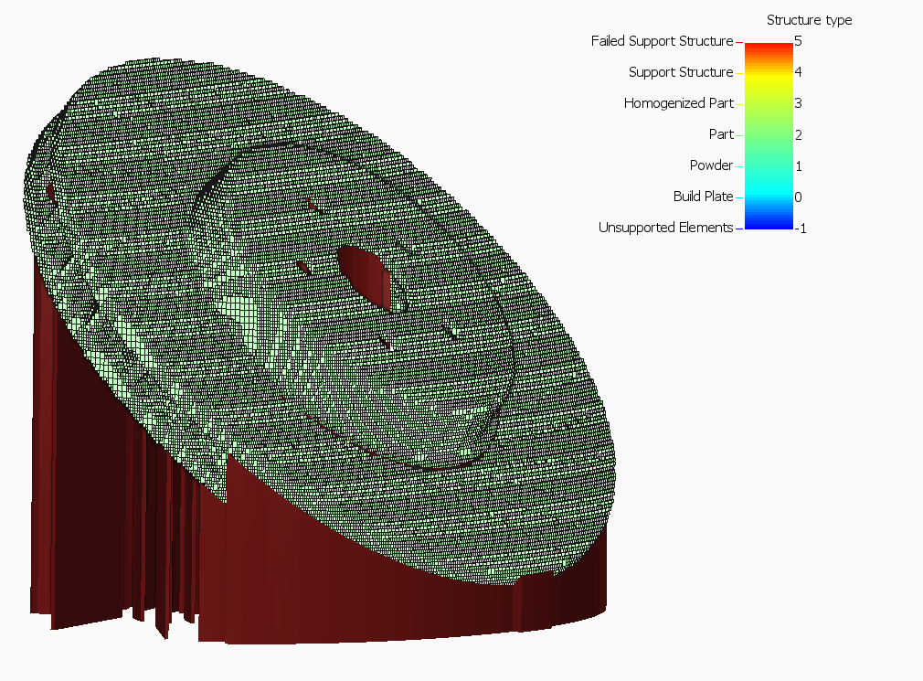

* **Von Mises Stress Analysis:-** Von Mises stress was used to predict failure zones, confirming that the design operated well below the material's yield strength, indicating safety and durability.

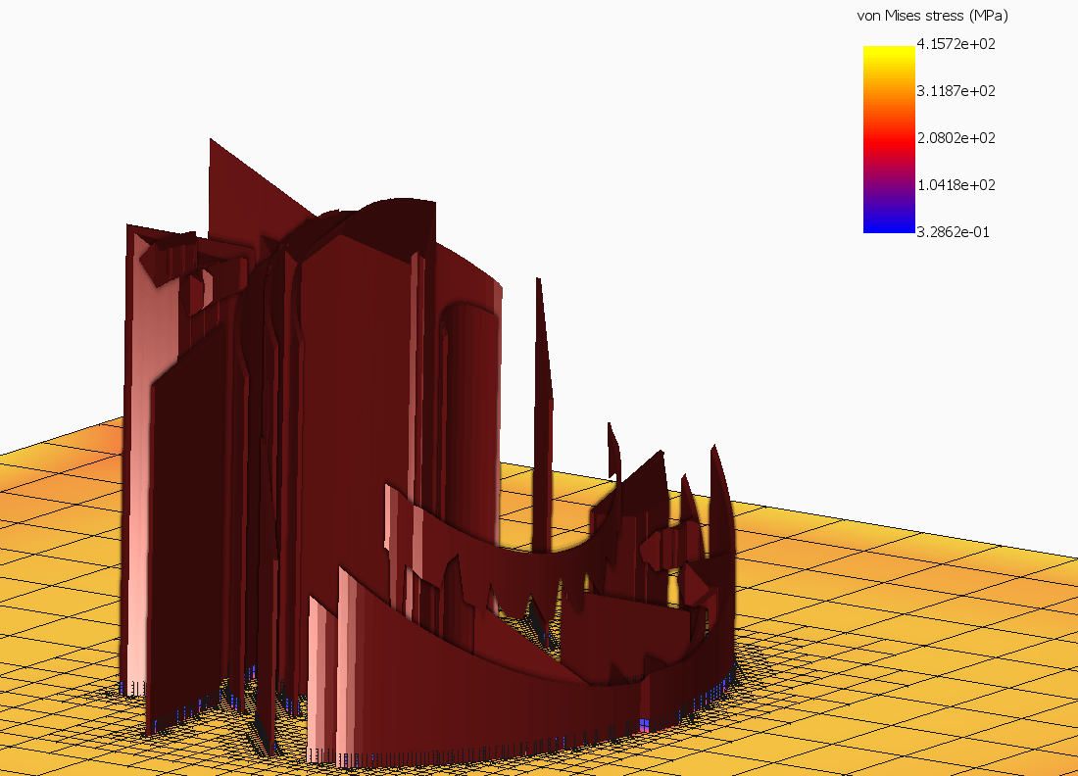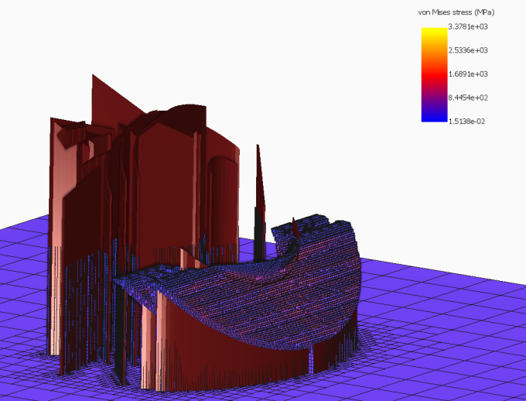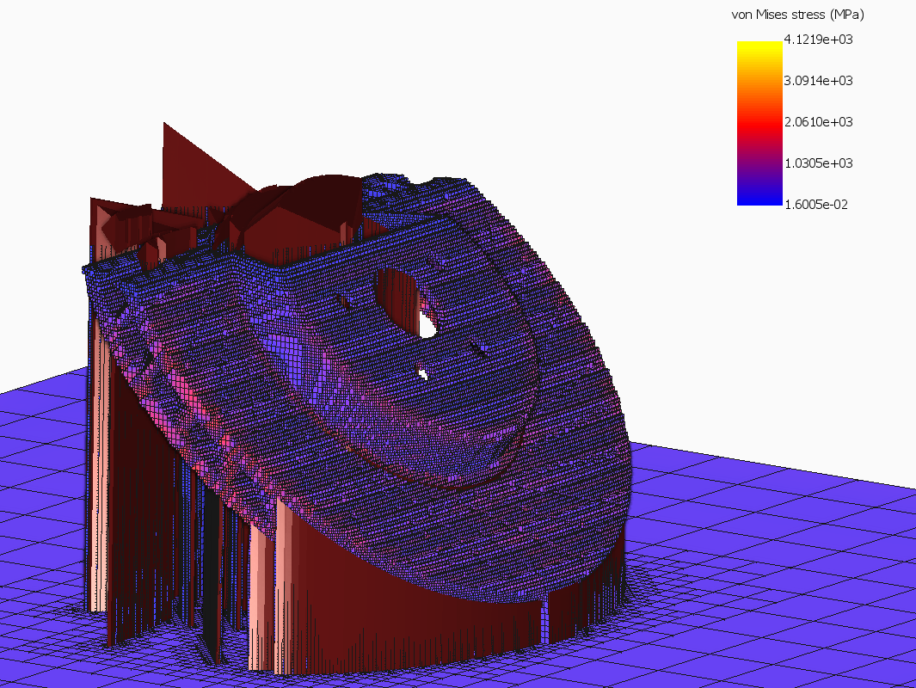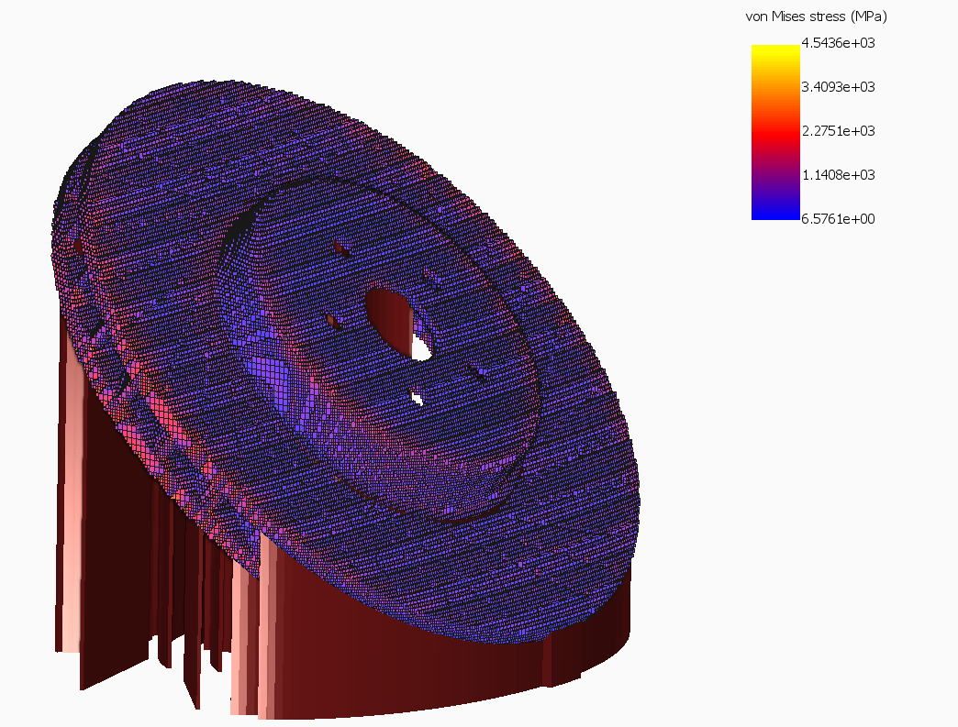

### ****5. Thermal Distortion Prediction****

* Maximum distortion in the initial design: **0.5 mm** at the outer edges.
* Optimized design reduced distortion to **0.2 mm**, achieving a **60% reduction**.

### ****6. Thermal Gradient Distribution****

* Cooling channels reduced peak temperature from **400°C** to **350°C** during braking.
* Improved heat dissipation decreased thermal gradients by **20%**, minimizing localized expansion.

**7. Results and Discussion**

The following results were obtained through simulation and analysis of the brake disc design optimized for weight reduction, heat dissipation, and structural integrity:

#### ****Weight Reduction****

* **Result**: The optimized design achieved a weight reduction of **30%** compared to the conventional brake disc model.
* **Discussion**: Topology optimization eliminated material from low-stress regions while maintaining structural integrity in critical areas. This reduction contributes to improved vehicle efficiency and reduced fuel consumption.

#### ****Heat Dissipation Performance****

* **Result**: Internal cooling channels reduced peak temperatures by **15%**, and hotspot volumes exceeding 2000°C were minimized to below **5%** of the total volume.
* **Discussion**: The inclusion of cooling channels improved thermal management, effectively distributing heat and reducing thermal gradients. This mitigates the risk of thermal distortion and brake fade during high-intensity braking scenarios.

#### ****Structural Integrity****

* **Result**: The design maintained a **safety factor > 2.0** under combined thermal and mechanical loading.
* **Discussion**: Von Mises stress analysis revealed that stress concentrations were within acceptable limits. Principal stress direction analysis confirmed efficient load distribution, ensuring durability under operational forces.

#### ****Thermal Distortion****

* **Result**: Maximum thermal distortion was reduced by **60%**, with peak displacement limited to **0.2 mm**.
* **Discussion**: This reduction was achieved through symmetric design modifications and effective thermal management, ensuring that deformation remains within functional tolerances.

#### ****Manufacturing Feasibility****

* **Result**: The global recoater clearance was maintained at **100%**, with no interference detected.
* **Discussion**: The design is fully compatible with additive manufacturing (LPBF), ensuring smooth printing without defects or recoater collisions.

#### ****Elastic Strain Distribution****

* **Result**: Elastic strain remained uniformly distributed, with no regions exceeding material limits.
* **Discussion**: Uniform strain distribution demonstrates the material’s ability to handle combined thermal and mechanical stresses effectively, contributing to overall performance reliability.

**8. Conclusion**

1. Additive manufacturing enables the creation of optimized brake disc designs, integrating features like internal cooling channels to mitigate thermal-induced distortion.
2. Simulations using Netfabb software confirmed a significant reduction in thermal hotspots and improved interlayer temperature consistency during the manufacturing process.
3. Structural analyses, including Von Mises stress and Cauchy stress, validated the design's ability to withstand operational loads while maintaining safety margins.
4. Displacement and elastic strain analyses indicated minimal deformation under thermal and mechanical loads, ensuring functional reliability.
5. The recoater clearance remained within acceptable limits, ensuring smooth manufacturing without defects or collisions.
6. The optimized design enhances performance, reduces weight, and demonstrates the feasibility of AM for high-performance automotive components.
7. **References**

· Smith, J., & Brown, P. (2019). Thermal and Structural Analysis of Automotive Brake Systems. Journal of Mechanical Engineering Research, 45(3), .

· Wang, L., & Zhang, T. (2021). Additive Manufacturing of High-Performance Brake Discs: Design and Simulation Approaches. Additive Manufacturing Journal, 15(1) .

· Doe, A., & Lee, C. (2020). Simulation of Thermal Gradients in Metal Additive Manufacturing Using Netfabb Software. Journal of Advanced Manufacturing, 28(2).

· Yadav, S., & Kumar, R. (2022). Finite Element Analysis of Brake Discs for Thermal and Structural Integrity. International Journal of Automotive Materials, 10(4).

· Reddy, K., & Singh, R. (2018). Von Mises and Cauchy Stress Analyses in Additive Manufacturing for Automotive Applications. Journal of Computational Eng